SECTION-3 - (JavaScript assignments) Steps to follow:

1. Create a new branch ‘js-assignments’.



1. Switch to ‘js-assignments’ branch.



1. Copy all JavaScript assignments inside ‘Assignments’ folder.

---copied successfully

1. Commit JavaScript assignments into ‘js-assignments’ branch.

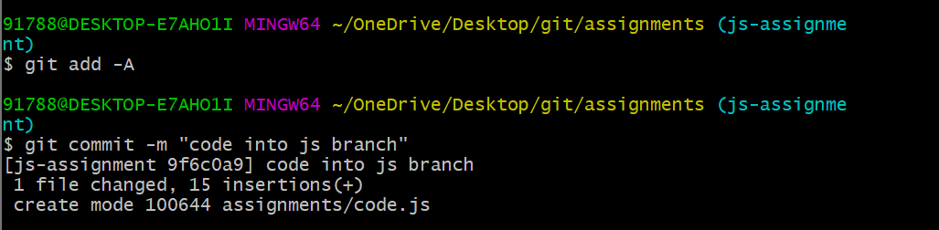

1. Make minor changes into README.txt file on line 1 belonging to ‘js-assignments’ branch.

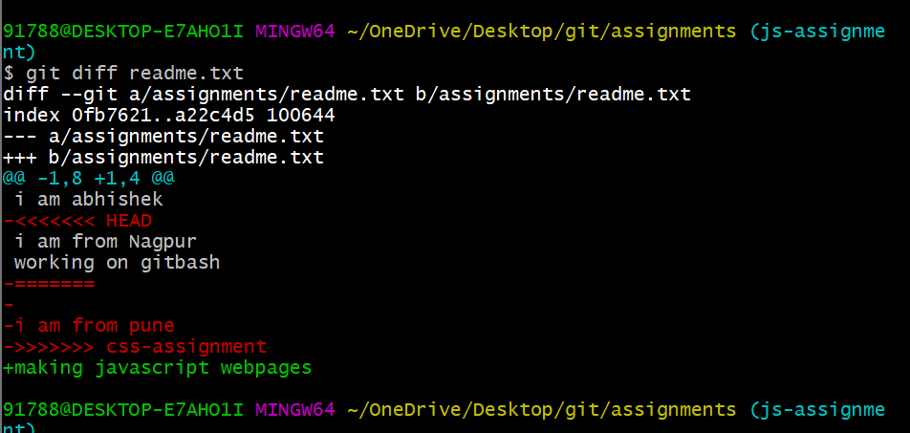

1. Commit those changed files.

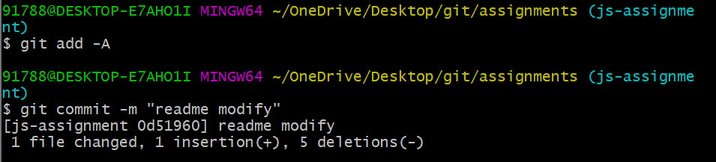

1. Switch to master branch.

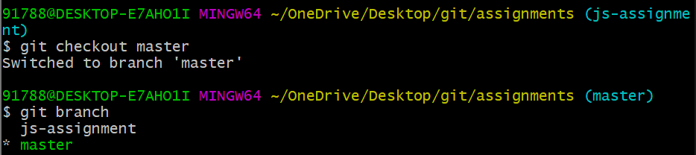

1. Make minor changes into README.txt file on line 1 & commit those changes into master.

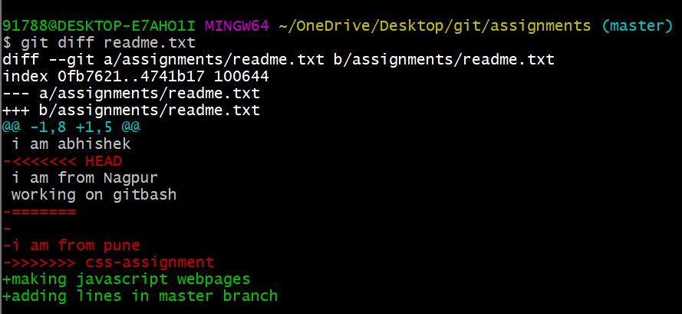

1. Again switch to ‘js-assignments’ branch.

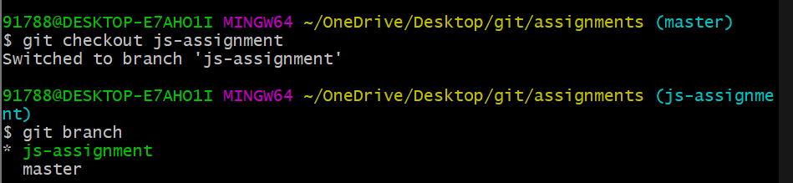

10. Make minor changes into few files belonging to ‘js-assignments’ branch.

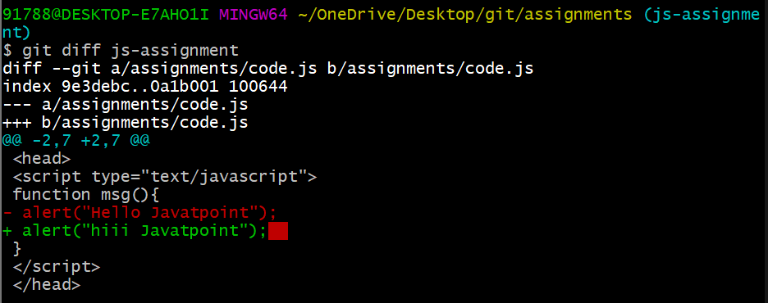

11. Commit those changes.

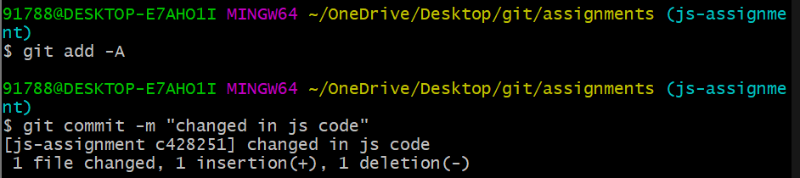

12. Switch to master.

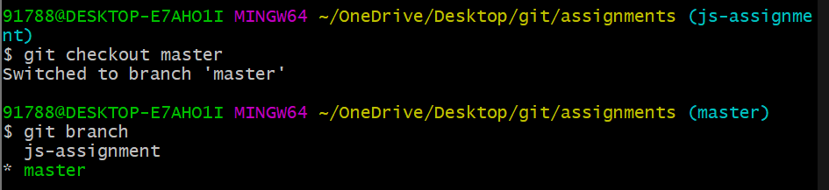

13. Merge ‘js-assignments’ branch into master. Confirm all JavaScript assignments are shown in master.

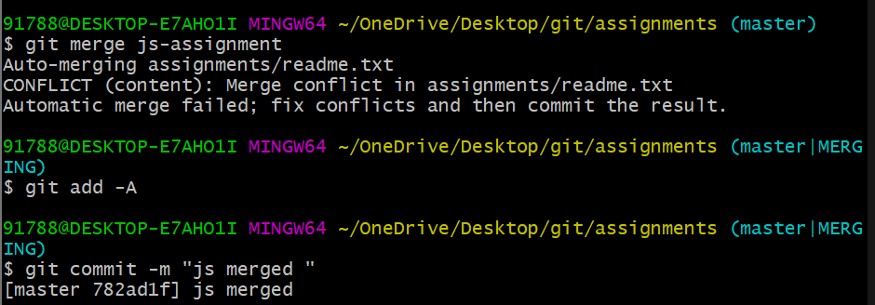

14. Finally delete the ‘js-assignments’ branch.

